Vm serveurLinux

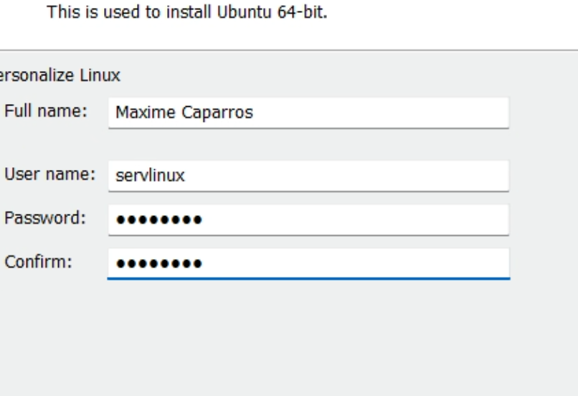

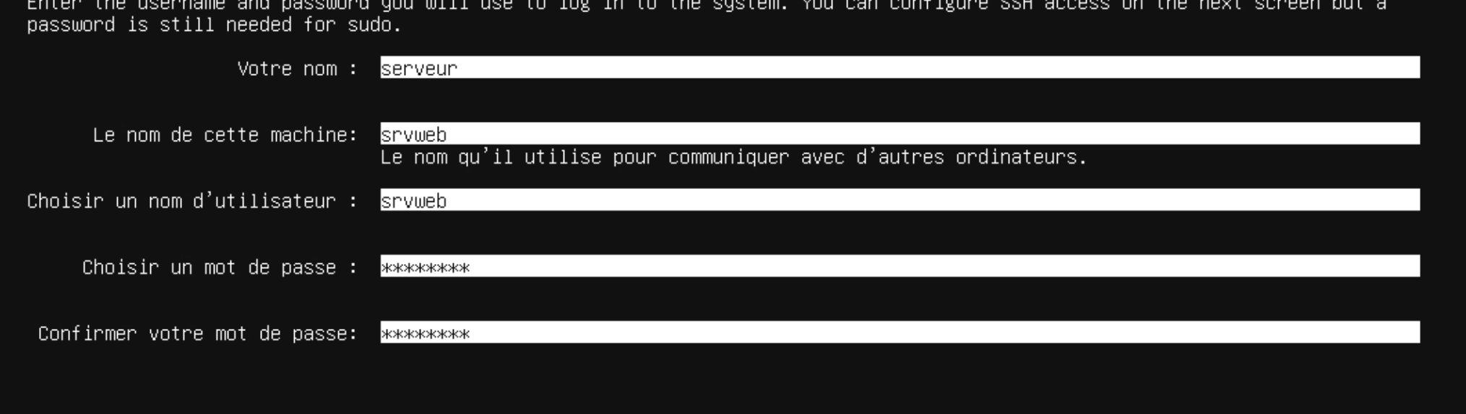

# Setup docker compose.

On va créer un network nextcloud ou on y affectera tous nos container afin qu’ils puissent communiquer entre eux :



Voici notre docker compose sans nextcloud:

version: "3.8"

volumes:

  nextcloud:

  db:

secrets:

  JWT_SECRET:

    file: authelia/secrets/JWT_SECRET

  SESSION_SECRET:

    file: authelia/secrets/SESSION_SECRET

  STORAGE_PASSWORD:

    file: authelia/secrets/STORAGE_PASSWORD

  STORAGE_ENCRYPTION_KEY:

    file: authelia/secrets/STORAGE_ENCRYPTION_KEY

  PASSWORD:

    file: authelia/secrets/PASSWORD

networks:

  net:

    external: true

    name: nextcloud

services:

  authelia:

    container_name: authelia

    image: docker.io/authelia/authelia:latest

    restart: unless-stopped

    networks:

      net:

        aliases:

          - "auth.maxcaptab.fr"

    expose:

      - 9091

    secrets: [JWT_SECRET, SESSION_SECRET, STORAGE_PASSWORD, STORAGE_ENCRYPTION_KEY]

    environment:

      AUTHELIA_JWT_SECRET_FILE: /run/secrets/JWT_SECRET

      AUTHELIA_SESSION_SECRET_FILE: /run/secrets/SESSION_SECRET

      AUTHELIA_STORAGE_ENCRYPTION_KEY_FILE: /run/secrets/STORAGE_ENCRYPTION_KEY

    volumes:

      - ./authelia/config:/config

    labels:

      - 'traefik.enable=true'

      - 'traefik.http.routers.authelia.rule=Host(`auth.maxcaptab.fr`)'

      - 'traefik.http.routers.authelia.entryPoints=https'

      - 'traefik.http.routers.authelia.tls=true'

      - 'traefik.http.middlewares.authelia.forwardAuth.address=http://authelia:9091/api/verify?rd=https%3A%2F%2Fauth.maxcaptab.fr%2F'

      - 'traefik.http.middlewares.authelia.forwardAuth.trustForwardHeader=true'

      - 'traefik.http.middlewares.authelia.forwardAuth.authResponseHeaders=Remote-User,Remote-Groups,Remote-Name,Remote-Email'

      - 'traefik.http.middlewares.authelia-basic.forwardAuth.address=http://authelia:9091/api/verify?auth=basic'

      - 'traefik.http.middlewares.authelia-basic.forwardAuth.trustForwardHeader=true'

      - 'traefik.http.middlewares.authelia-basic.forwardAuth.authResponseHeaders=Remote-User,Remote-Groups,Remote-Name,Remote-Email'

      #- "traefik.http.routers.authelia.tls.certresolver=myresolver"

  traefik:

    container_name: traefik

    image: traefik:v2.9

    restart: unless-stopped

    command:

      - '--api=true'

      - '--api.dashboard=true'

      - '--api.insecure=false'

      - '--pilot.dashboard=false'

      - '--global.sendAnonymousUsage=false'

      - '--global.checkNewVersion=false'

      - '--log=true'

      - '--log.level=DEBUG'

      - '--log.filepath=/config/traefik.log'

      - '--providers.docker=true'

      - '--providers.docker.exposedByDefault=false'

      - '--entryPoints.http=true'

      #- "--entrypoints.http.redirections.entrypoint.to=https"

      #- "--entrypoints.http.redirections.entrypoint.scheme=https"

      - '--entryPoints.http.address=:80/tcp'

      ## Please see the Forwarded Header Trust section of the Authelia Traefik Integration documentation.

      - '--entryPoints.http.forwardedHeaders.trustedIPs=10.0.1.0/24,192.168.10.0/24,192.168.20.0/24,127.0.0.0/8'

      - '--entryPoints.http.proxyProtocol.trustedIPs=10.0.1.0/24,192.168.10.0/24,192.168.20.0/24,127.0.0.0/8'

      - '--entryPoints.http.forwardedHeaders.insecure=false'

      - '--entryPoints.http.proxyProtocol.insecure=false'

      - '--entryPoints.https=true'

      - '--entryPoints.https.address=:443/tcp'

      ## Please see the Forwarded Header Trust section of the Authelia Traefik Integration documentation.

      - '--entryPoints.https.forwardedHeaders.trustedIPs=10.0.1.0/24,192.168.10.0/24,192.168.20.0/24,127.0.0.0/8'

      - '--entryPoints.https.proxyProtocol.trustedIPs=10.0.1.0/24,192.168.10.0/24,192.168.20.0/24,127.0.0.0/8'

      - '--entryPoints.https.forwardedHeaders.insecure=false'

      - '--entryPoints.https.proxyProtocol.insecure=false'

      #- "--certificatesresolvers.letsencrypt.acme.email=maxoucaparros@gmail.com"

      #- "--certificatesresolvers.letsencrypt.acme.storage=/config/acme.json"

      #- "--certificatesresolvers.letsencrypt.acme.caserver=https://acme-v02.api.letsencrypt.org/directory"

      #- "--certificatesresolvers.letsencrypt.acme.keytype=RSA4096"

      #- "--certificatesresolvers.letsencrypt.acme.dnschallenge=true"

      #- "--certificatesresolvers.letsencrypt.acme.dnschallenge.provider=cloudflare"

      #- "--certificatesresolvers.letsencrypt.acme.dnschallenge.delaybeforecheck=0"

      #- "--certificatesresolvers.letsencrypt.acme.dnschallenge.resolvers=1.1.1.1:53,8.8.8.8:53"

    networks:

          net: {}

    ports:

      - "80:80"

      - "443:443"

      - "8443:443"

      - "8080:80"

    volumes:

      - /var/run/docker.sock:/var/run/docker.sock

      - ./traefik/data/traefik:/config

      #- "./cert/:/certs/"

      #- ./letsencrypt:/letsencrypt

      #- ./acme.json:/acme.json

      #- ./traefik.yml:/etc/traefik/traefik.yml

    labels:

      - 'traefik.enable=true'

      #- 'traefik.http.routers.reverse-proxy.rule=Host(`maxcaptab.com`)'

      - 'traefik.http.routers.api.rule=Host(`traefik.maxcaptab.fr`)'

      - 'traefik.http.routers.api.entryPoints=https'

      - 'traefik.http.routers.api.tls=true'

      - 'traefik.http.routers.api.service=api@internal'

      - 'traefik.http.routers.api.middlewares=authelia@docker'

      #- "traefik.http.routers.api.tls.certresolver=myresolver"

    depends_on:

      - authelia

Installation de nextcloud :

Configuration de nextcloud :

On installe ensuite les applications recommandées :

Puis on se dirige dans l’es options d’administrations :

Application SSO :

